Project Design Phase-II
Data Flow Diagram & User Stories

Date | 15 July 2026
Team ID
Project Name | Book a Doctor – Online Doctor Appointment Booking System
Team Members | Anvesh Gudipalli (Team Lead), Kunasani Sravani, Parisi Rahul, Seelam Rukmini, Geethika Viri Mahitha Singidi
Maximum Marks | 4 Marks

Data Flow Diagrams:
A Data Flow Diagram (DFD) is a traditional visual representation of the information flows within a system. A neat and clear DFD can depict the right amount of the system requirement graphically. It shows how data enters and leaves the system, what changes the information, and where data is stored.
Example: DFD Level 0 (Industry Standard)
Example: (Simplified)
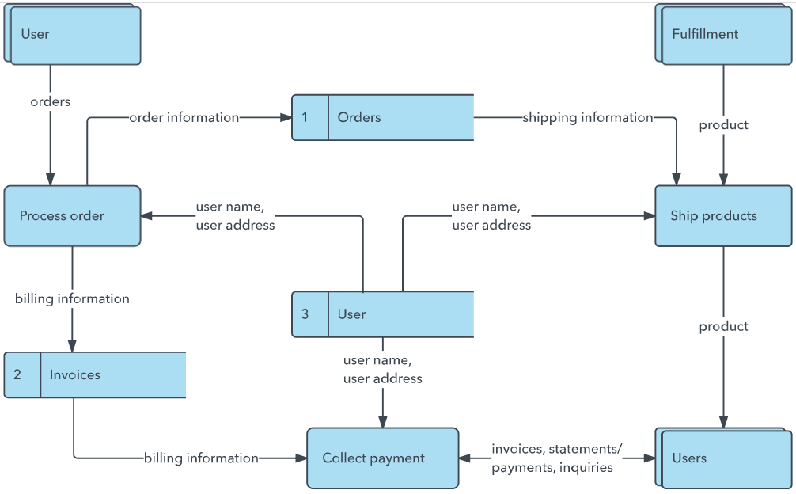


DFD for Book a Doctor (Team Diagram):
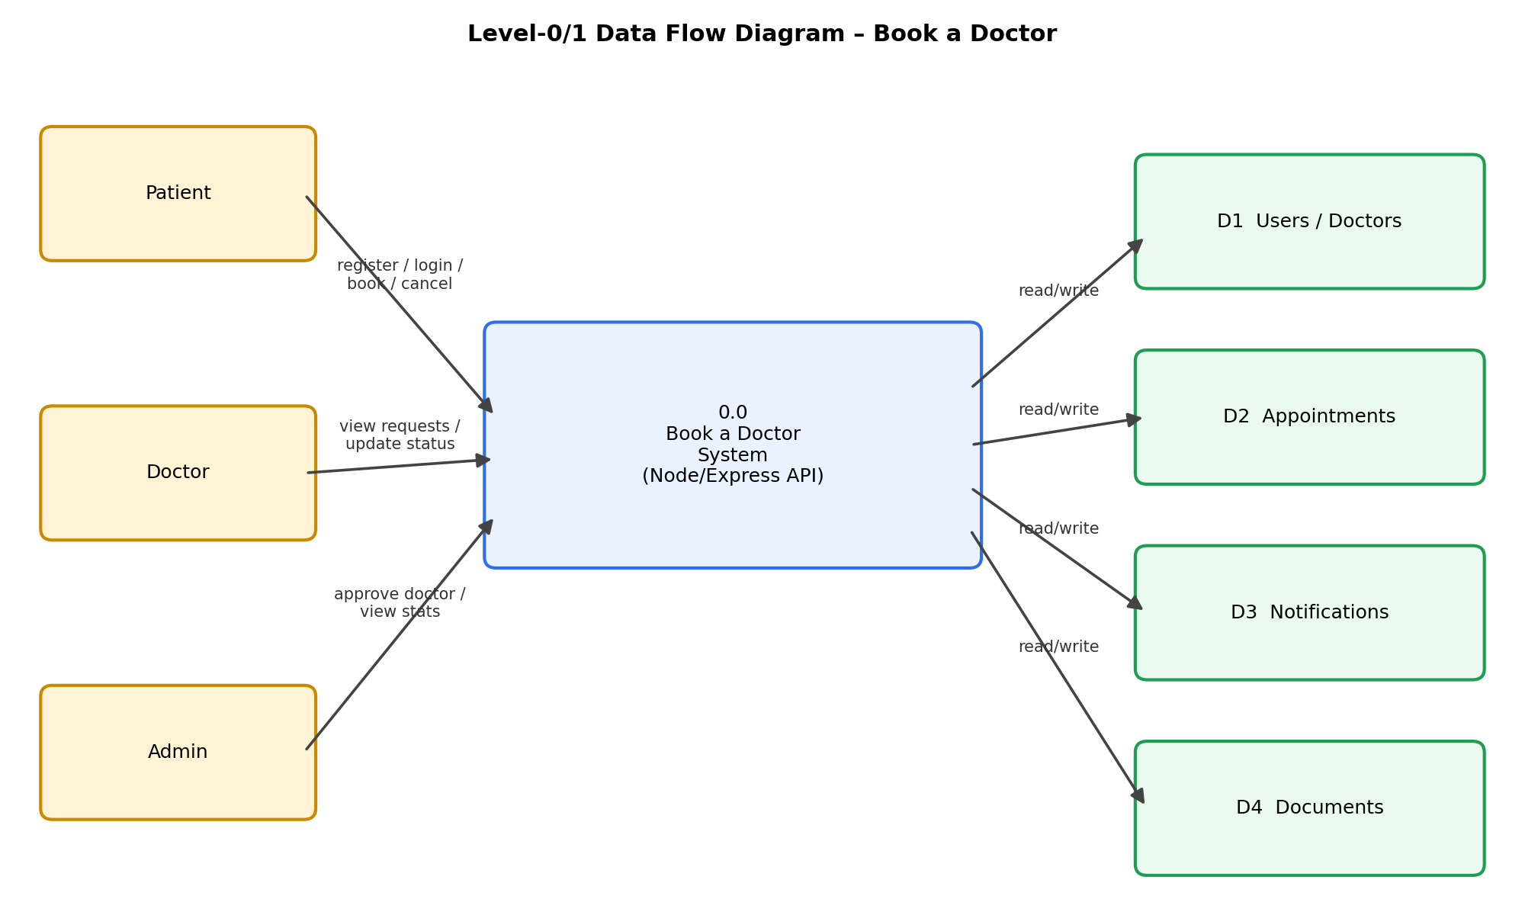
User Stories
Use the below template to list all the user stories for the product.
User Type | Functional Requirement (Epic) | User Story Number | User Story / Task | Acceptance criteria | Priority | Release
Patient | Registration | USN-1 | As a patient, I can register by entering my name, email, phone and password. | I can log in and access my patient dashboard | High | Sprint-1
 |  | USN-2 | As a patient, I receive a JWT session token once I log in successfully. | I stay logged in and can access protected pages | High | Sprint-1
 | Doctor Search | USN-3 | As a patient, I can browse and search approved doctors by name or specialization. | I can find a relevant doctor from the list | High | Sprint-1
 | Booking | USN-4 | As a patient, I can book an appointment by choosing a date, time slot and reason. | The appointment appears in my dashboard as pending | High | Sprint-2
 | Dashboard | USN-5 | As a patient, I can view, and cancel, my upcoming and past appointments. | Cancelled appointments show status 'cancelled' | Medium | Sprint-2
 | Document Upload | USN-6 | As a patient, I can upload a medical document against an appointment. | The uploaded file appears in the appointment record | Medium | Sprint-3
Doctor | Registration | USN-7 | As a doctor, I can register with my specialization and consultation fee. | My profile is created pending admin approval | High | Sprint-1
 | Dashboard | USN-8 | As a doctor, I can view all appointment requests assigned to me. | I can see patient name, date, time and reason | High | Sprint-3
 |  | USN-9 | As a doctor, I can confirm, complete or cancel an appointment. | Patient receives a notification of the status change | High | Sprint-3
Admin | Approval | USN-10 | As an admin, I can review and approve newly registered doctors. | Approved doctors appear in patient search results | High | Sprint-4
 | Dashboard | USN-11 | As an admin, I can view platform statistics (users, doctors, appointments). | Stats reflect current DB counts | Medium | Sprint-4
 | User Management | USN-12 | As an admin, I can view all users and deactivate an account. | Deactivated users can no longer log in | Medium | Sprint-4
All Users | Notifications | USN-13 | As a user, I can view my notifications and mark them read. | Unread count updates after marking as read | Low | Sprint-3

